**VISVESVARAYA TECHNOLOGICAL UNIVERSITY**

**“JnanaSangama”, Belgaum -590014, Karnataka.**



**LAB REPORT on**

Big Data Analytics (23CS6PCBDA)

***Submitted by:***

# Prerana Meda Krishna (1BM22CS209)

**Under the Guidance of Vikranth B.M.**

**Assistant Professor, BMSCE**

***in partial fulfillment for the award of the degree of***

**BACHELOR OF ENGINEERING**

***in***

**COMPUTER SCIENCE AND ENGINEERING**



**B.M.S. COLLEGE OF ENGINEERING**

**(Autonomous Institution under VTU)**

**BENGALURU-560019 March 2025 - June 2025**

**B. M. S. College of Engineering,**

**Bull Temple Road, Bangalore 560019**

(Affiliated To Visvesvaraya Technological University, Belgaum)

**Department of Computer Science and Engineering**



**CERTIFICATE**

This is to certify that the Lab work entitled “**Big Data Analytics**” carried out by **Prerana Meda Krishna (1BM22CS209),** who is bonafide student of **B. M. S. College of Engineering.** It is in partial fulfillment for the award of **Bachelor of Engineering in Computer Science and Engineering** of the Visvesvaraya Technological University, Belgaum during the year 2024. The Lab report has been approved as it satisfies the academic requirements in respect of **Big Data Analytics –(23CS6PCBDA)** work prescribed for the said degree.

**Vikranth B.M Dr. Kavitha Sooda**

Associate Professor Professor and Head

Department of CSE Department of CSE

BMSCE, Bengaluru BMSCE, Bengaluru

**Table Of Contents**

|  |  |  |
| --- | --- | --- |
| **Sl.no** | **Program details** | **Pg no** |
| 1 | MongoDB- CRUD Operations Demonstration (Practice and Self Study) | 1-8 |
| 2 | Perform the DB operations using Cassandra. | 9-14 |
| 3 | Perform the DB operations using Cassandra | 15-18 |
| 4 | Execution of HDFS Commands for interaction with Hadoop Environment. (Minimum 10 commands to be executed) | 19-20 |
| 5 | Implement Wordcount program on Hadoop framework | 21-25 |
| 6 | 1. Create a MapReduce program to find average temperature for each year from the NCDC data set. 2. find the mean max temperature for every month. | 26-34 |
| 7 | For a given Text file, Create a Map Reduce program to sort the content in an alphabetic order listing only top 10 maximum occurrences of words. | 35-39 |
| 8 | Write a Scala program to print numbers from 1 to 100 using a for loop. | 40-41 |
| 9 | Using RDD and FlatMap count how many times each word appears in a file and write out a list of words whose count is strictly greater than 4 using Spark. | 42-43 |
| 10 | Write a simple streaming program in Spark to receive text data streams on a particular port, perform basic text cleaning (like white space removal, stop words removal, lemmatization, etc.), and print the cleaned text on the screen. (Open Ended Question). | 44-45 |

Github Link: https://github.com/Preranamk/BDA

# Program 1

**MongoDB- CRUD Operations Demonstration (Practice and Self Study)**

* Created a database named **myDB** and verified its existence.
* Created and dropped collections like **Student** and **Students**.
* Inserted student data into collections.
* Performed **upsert** to insert or update a student record.
* Used to find queries with various filters: by name, grade, hobbies, regex, etc.
* Retrieved specific fields while suppressing _id.
* Counted total documents and documents with specific criteria.
* Sorted records in ascending and descending order.
* Imported data from a CSV file and exported data to a CSV file.
* Used save() to insert or replace documents.
* Added, removed, and set fields to null in documents.
* Retrieved limited records and skipped initial entries.
* Created a **food** collection with arrays and queried arrays by value, index, size, etc.
* Updated specific elements in an array.
* Practiced query optimizations using $in, $all, $ne, $regex, $slice, and more.

**Observation:**

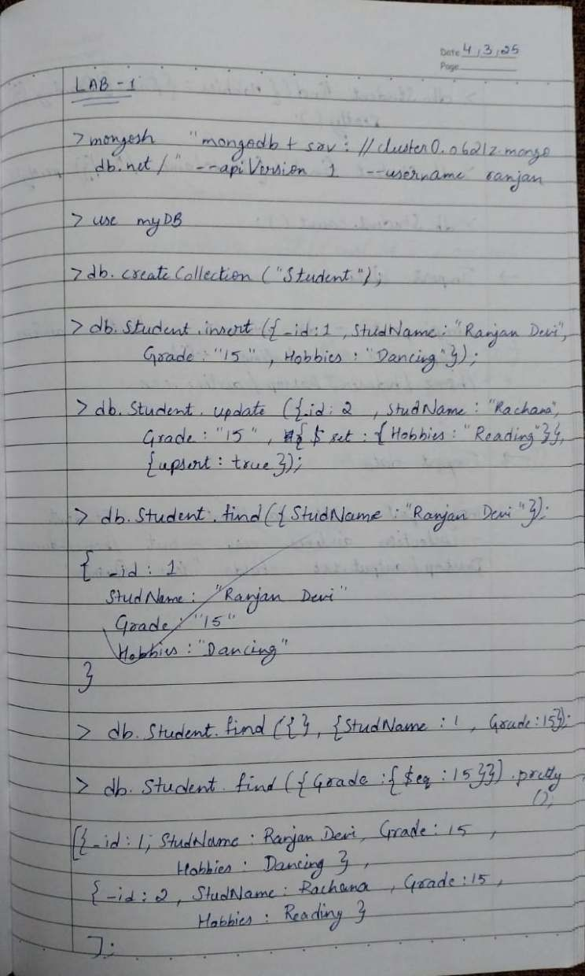

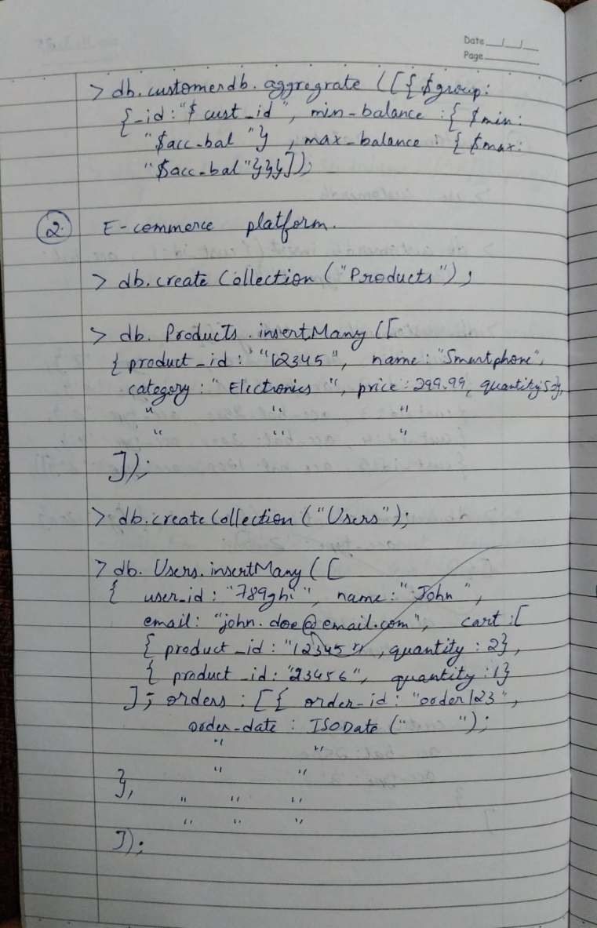

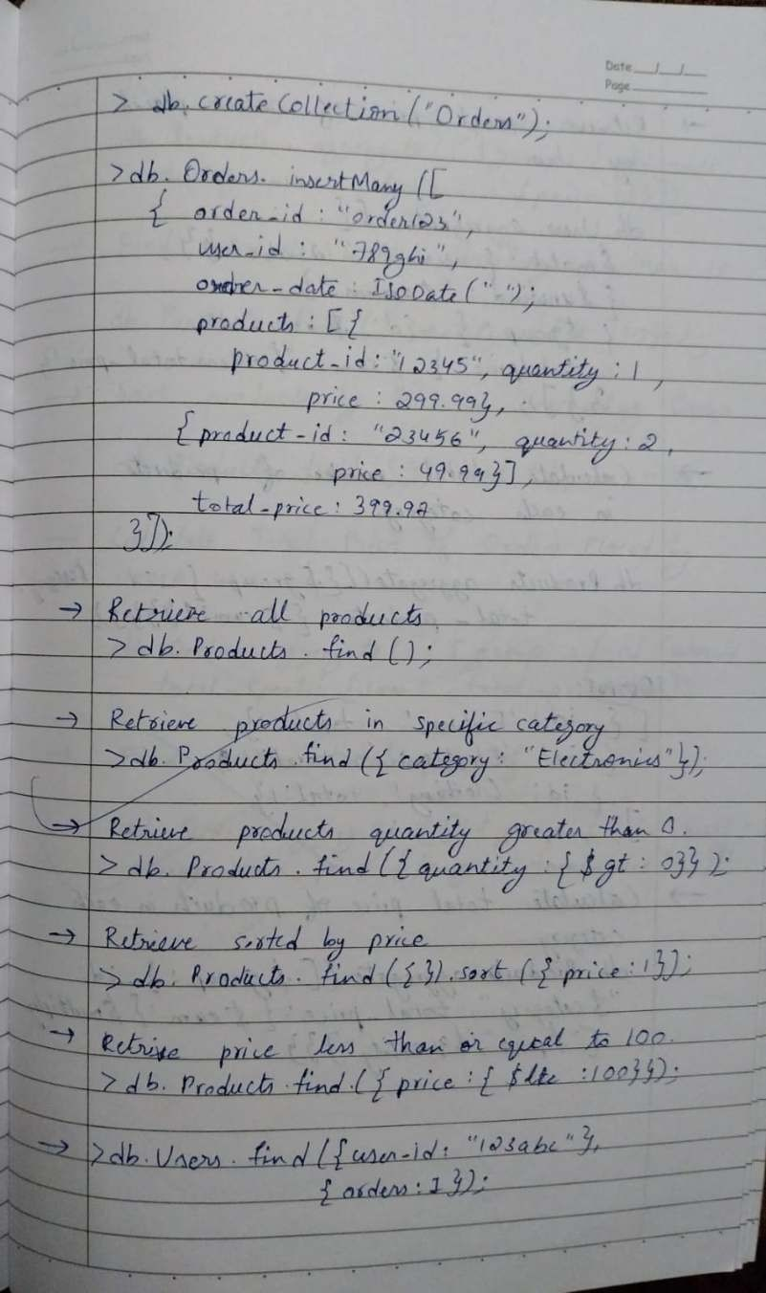

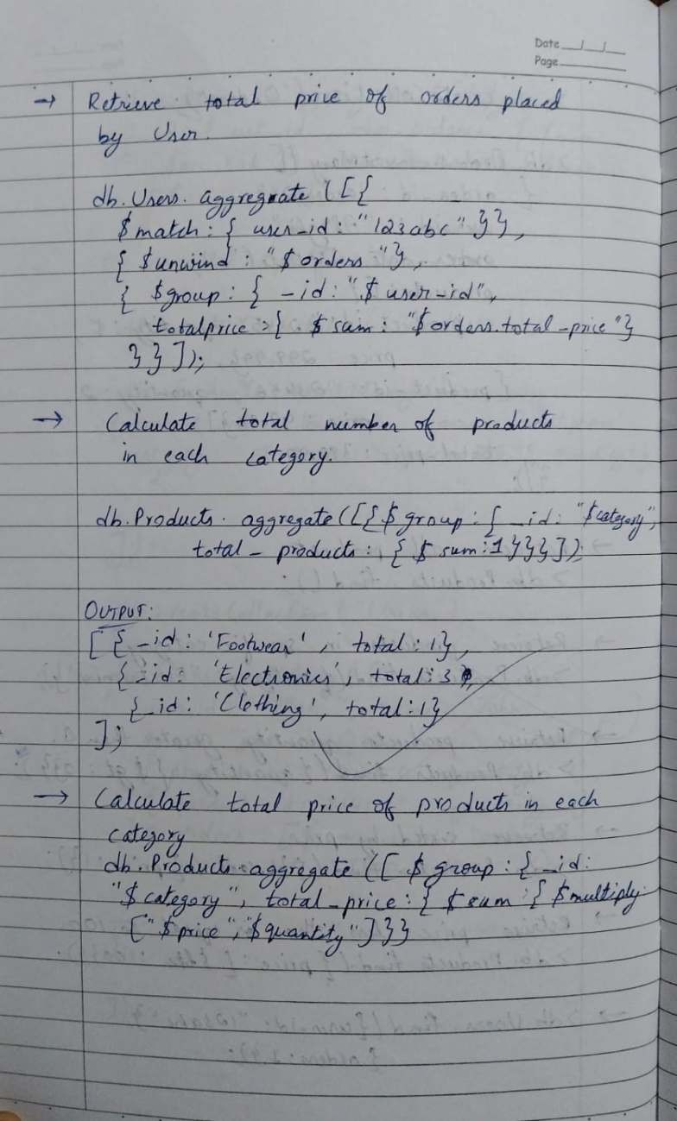

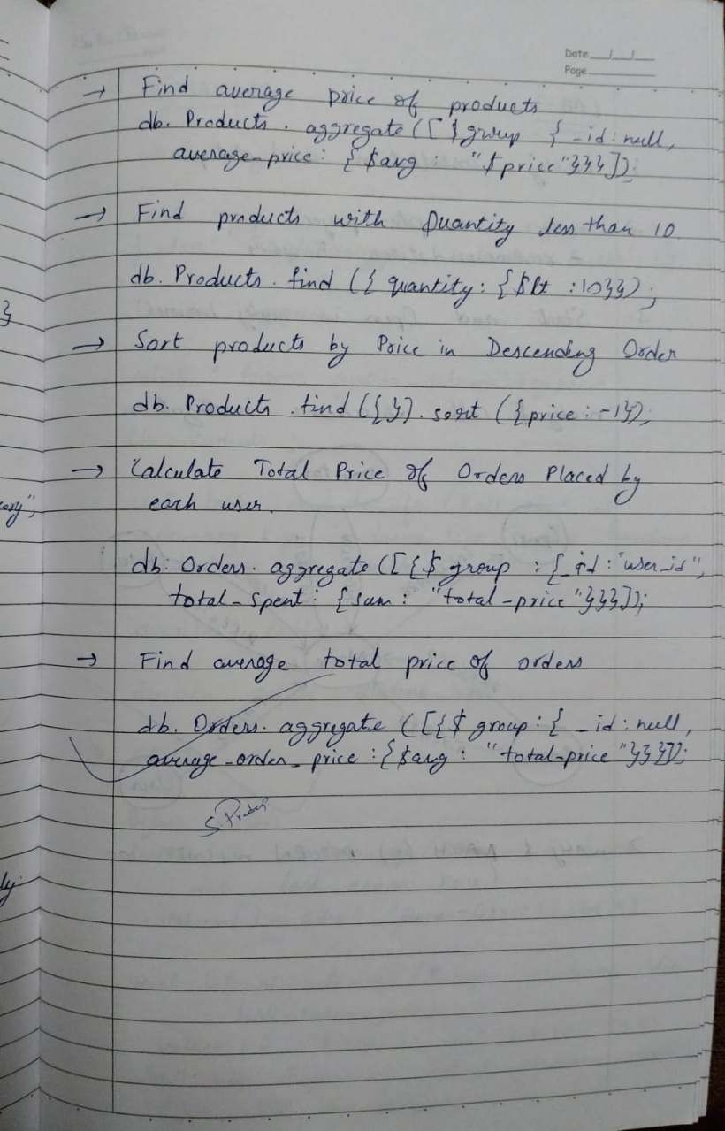

**Code with Output:**

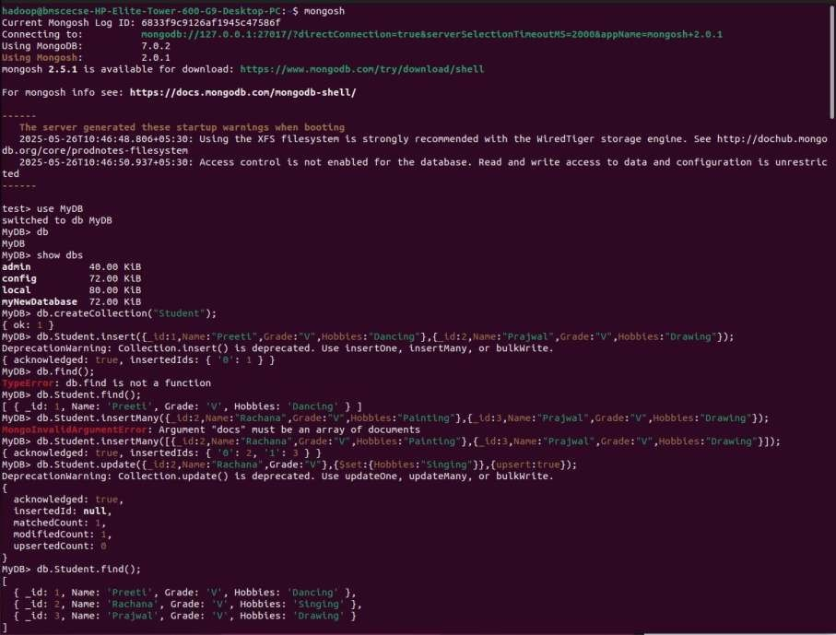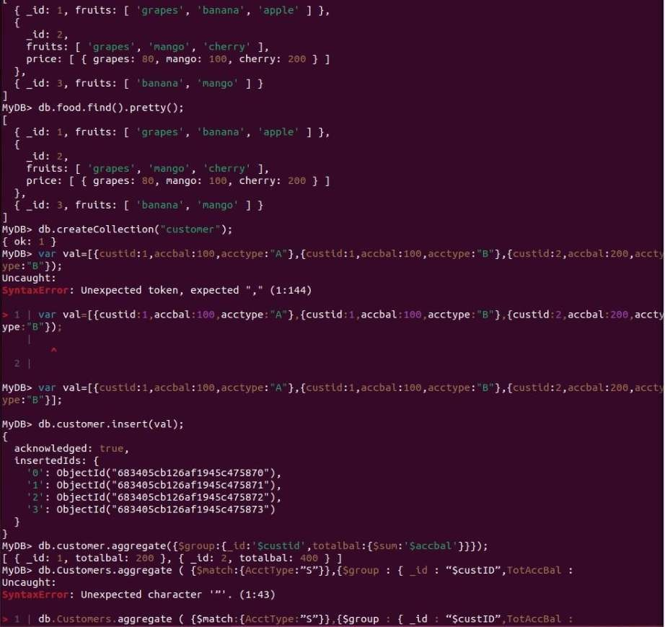

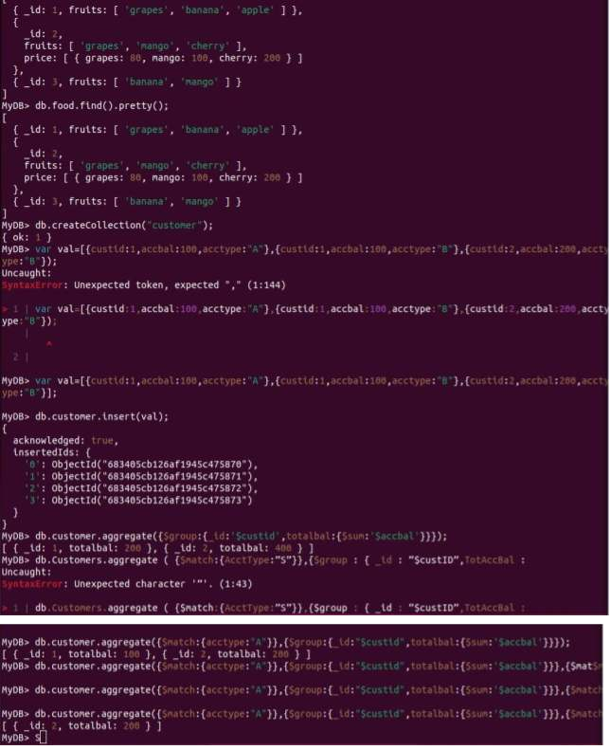

# Program 2

**Perform the following DB operations using Cassandra.**

1. Create a keyspace by name Employee
2. Create a column family by name

Employee-Info with attributes Emp_Id Primary Key, Emp_Name,

Designation, Date_of_Joining, Salary,

Dept_Name

1. Insert the values into the table in batch
2. Update Employee name and Department of Emp-Id 121
3. Sort the details of Employee records based on salary
4. Alter the schema of the table Employee_Info to add a column Projects which stores a set of Projects done by the corresponding Employee.
5. Update the altered table to add project names.
6. Create a TTL of 15 seconds to display the values ofEmployees.

**Observation:**

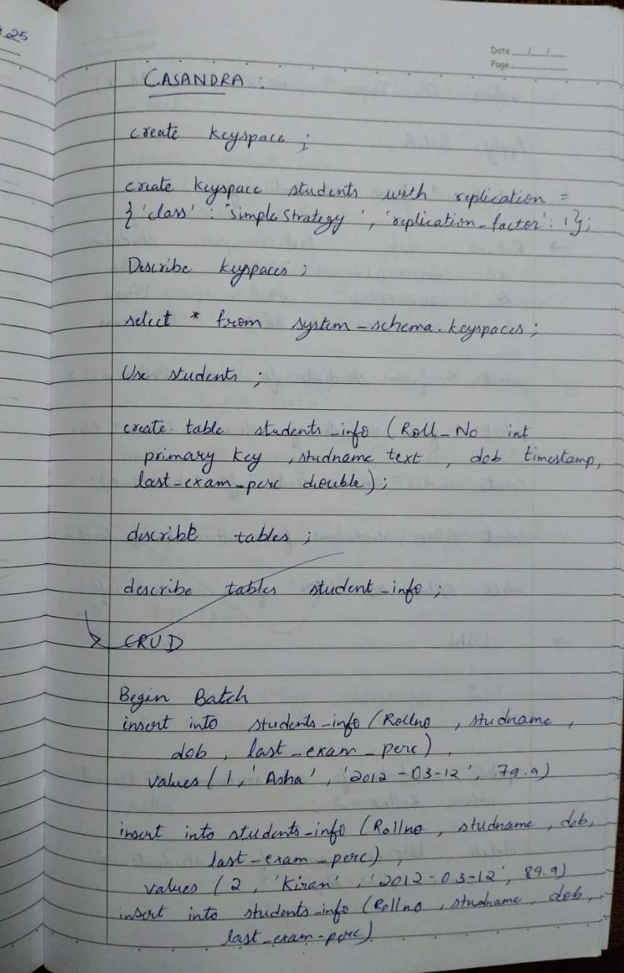

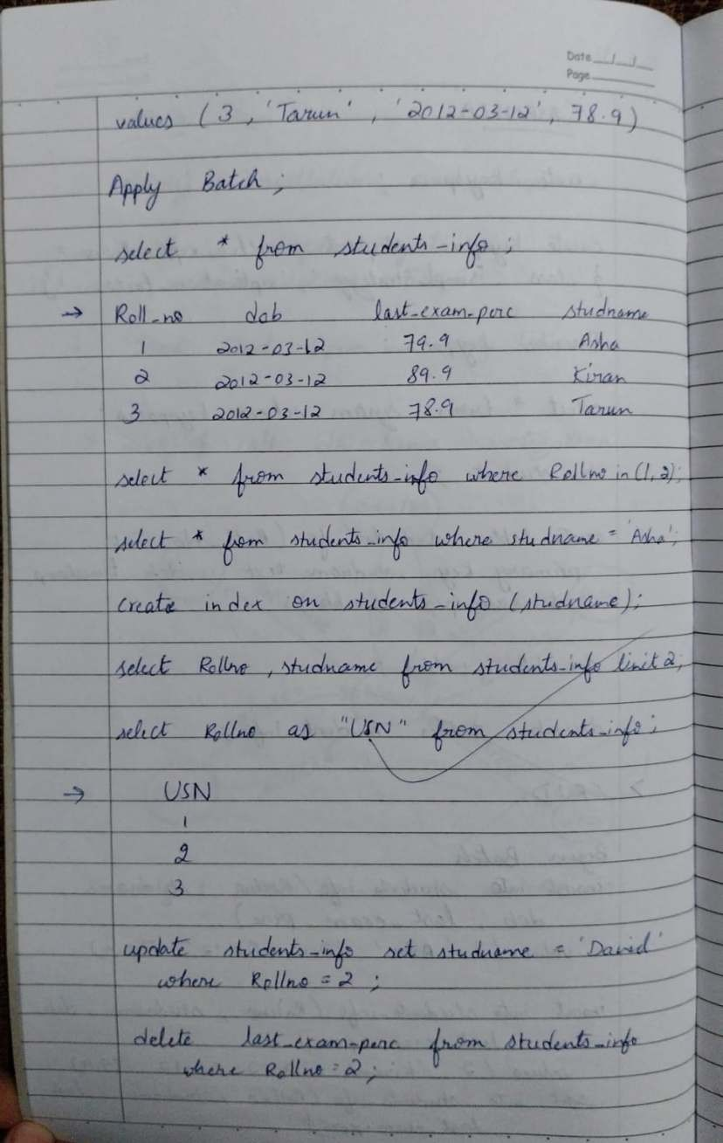

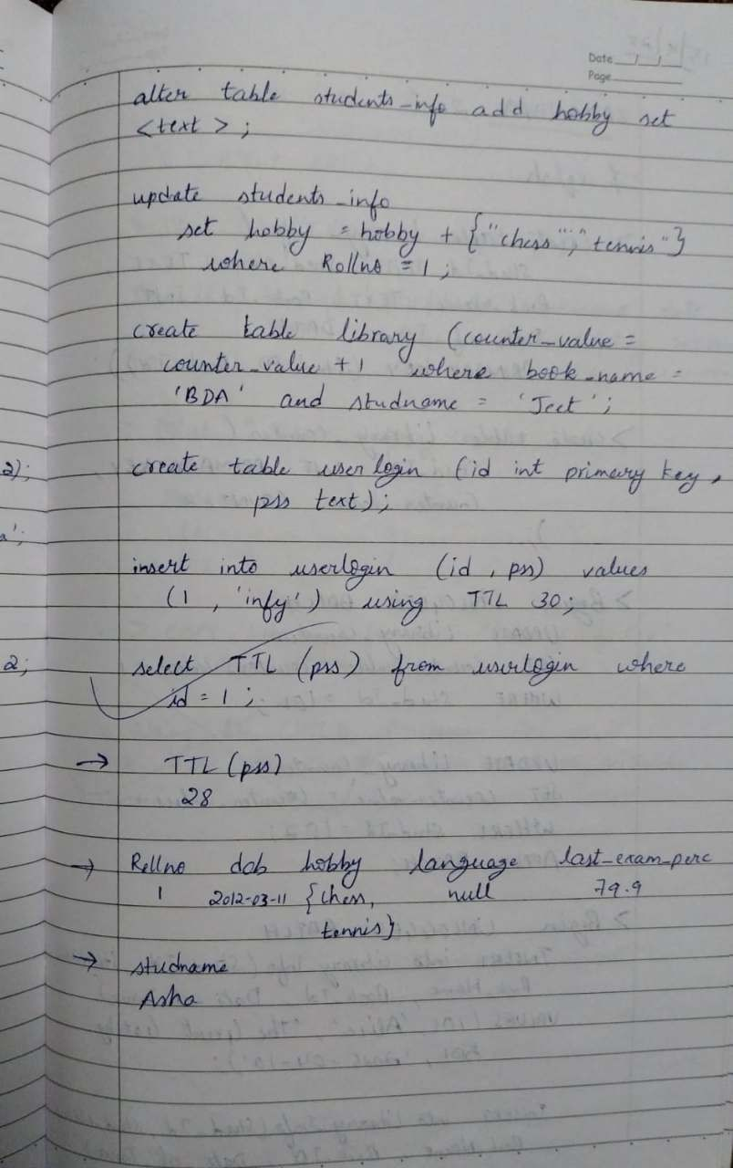

**Code with Output:**

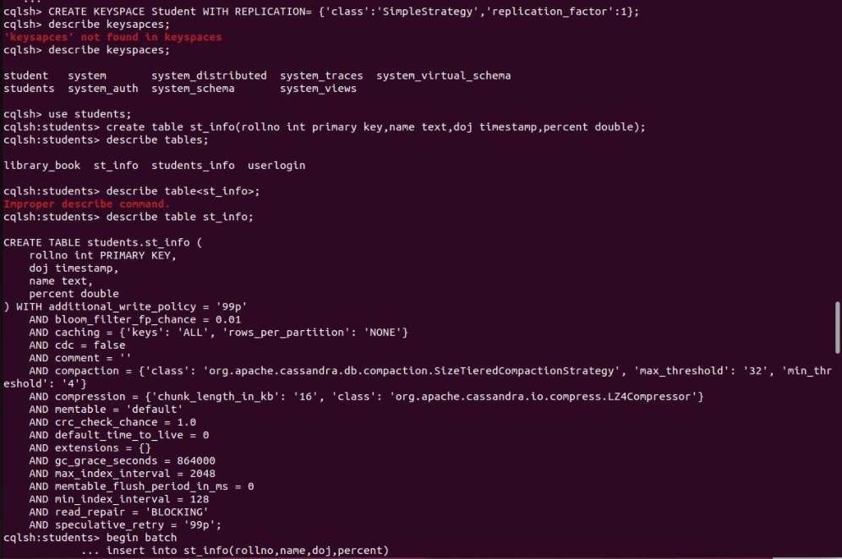

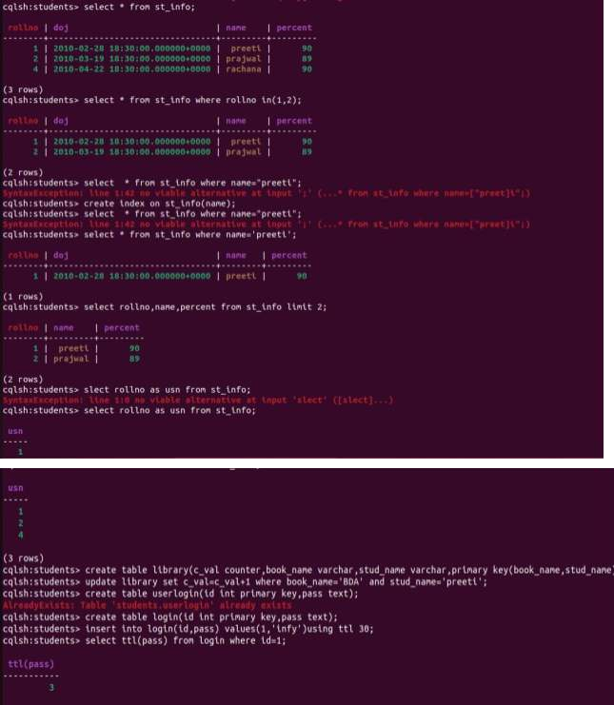

# Program 3

**Perform the following DB operations using Cassandra.**

1. Create a keyspace by name Library
2. Create a column family by name Library-Info with attributes Stud_Id Primary Key,

Counter_value of type Counter, Stud_Name,

Book-Name, Book-Id,

Date_of_issue

1. Insert the values into the table in batch
2. Display the details of the table created and increase the value of the counter
3. Write a query to show that a student with id 112 has taken a book “BDA” 2 times.
4. Export the created column to a csv file
5. Import a given csv dataset from local file system into Cassandra column family

**Observation:**

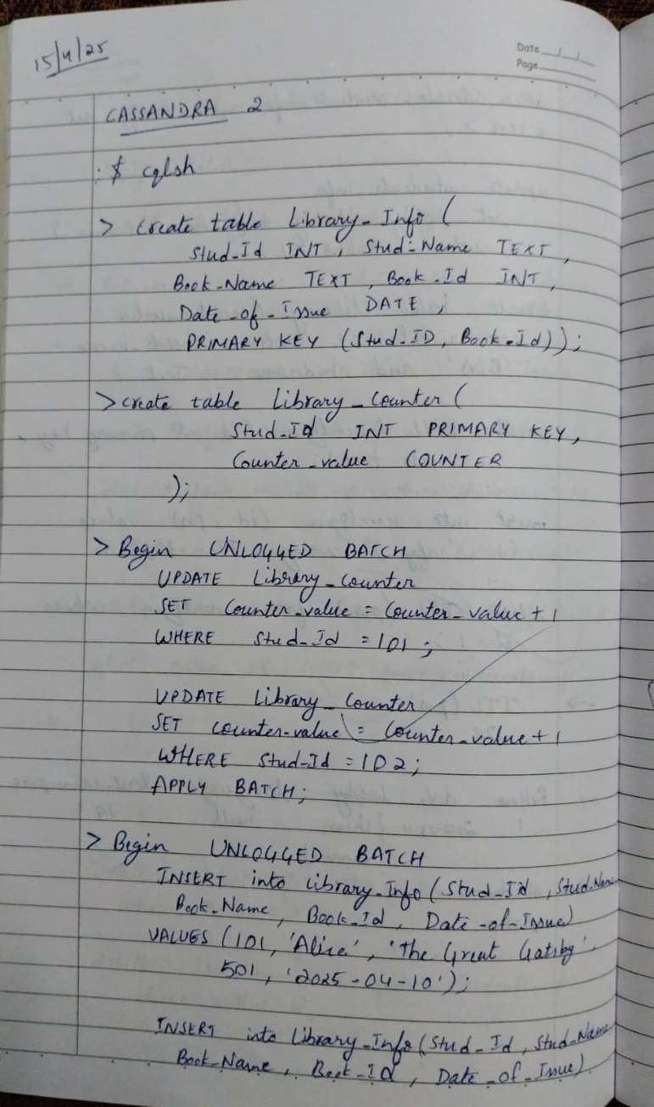

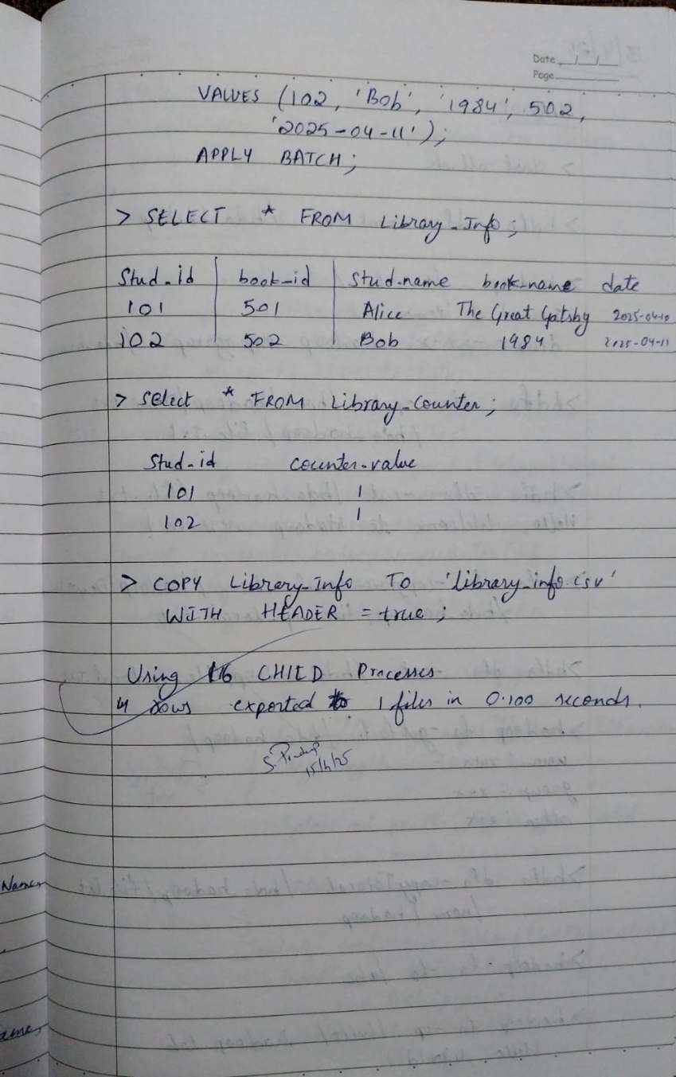

**Code with Output:**

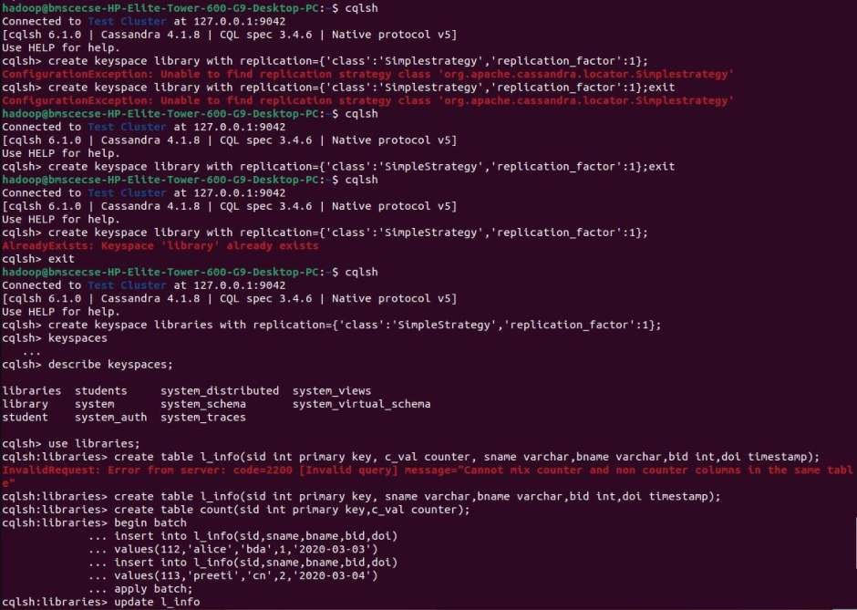

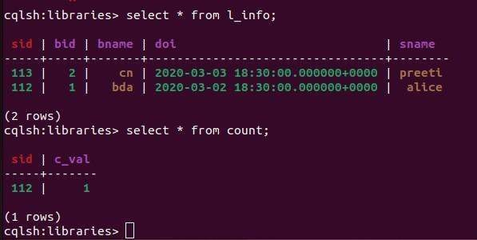

# Program 4

**Execution of HDFS Commands for interaction with Hadoop Environment. (Minimum 10 commands to be executed)**

**Observation:**

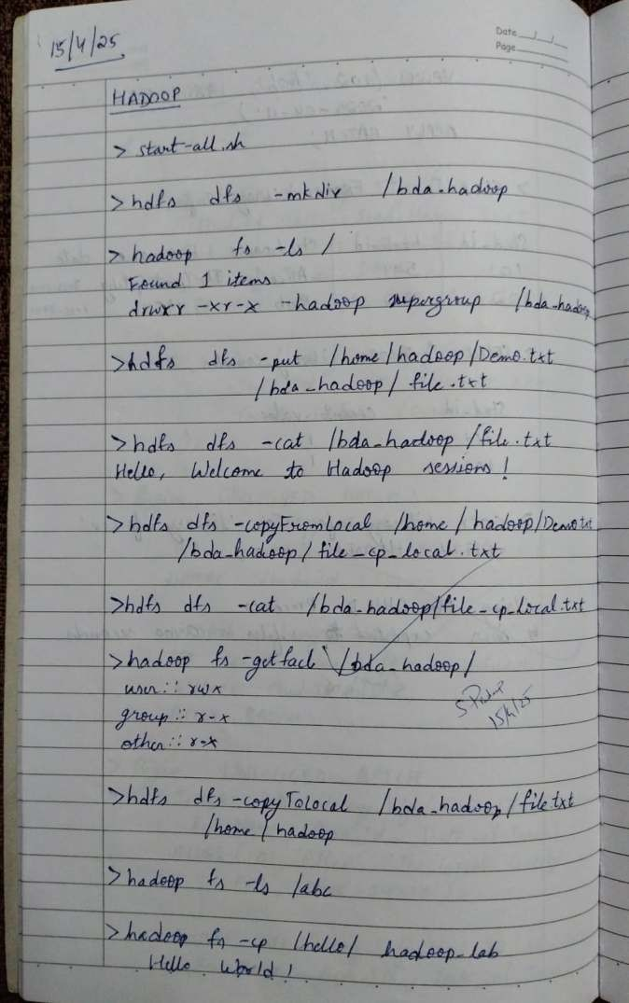

**Code with Output:**

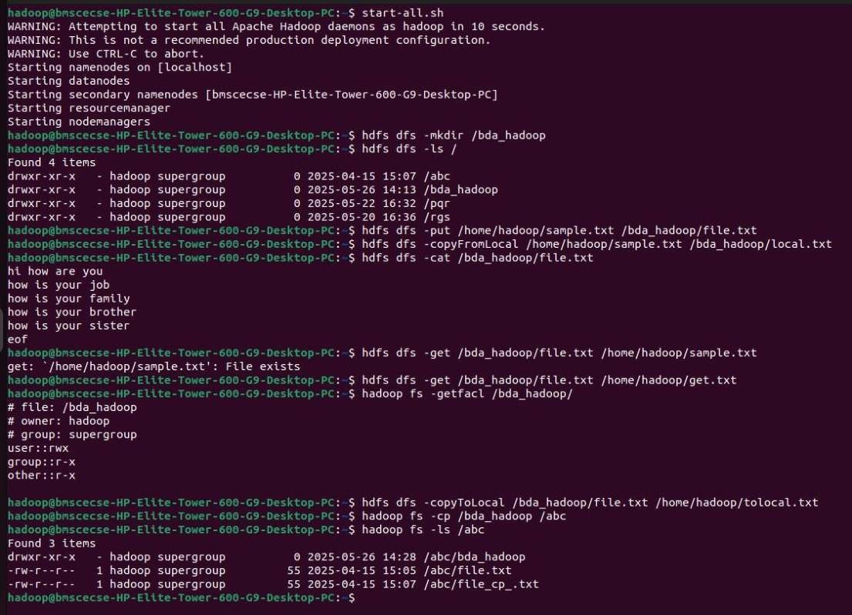

# Program 5

**Implement Wordcount program on Hadoop framework Observation:**

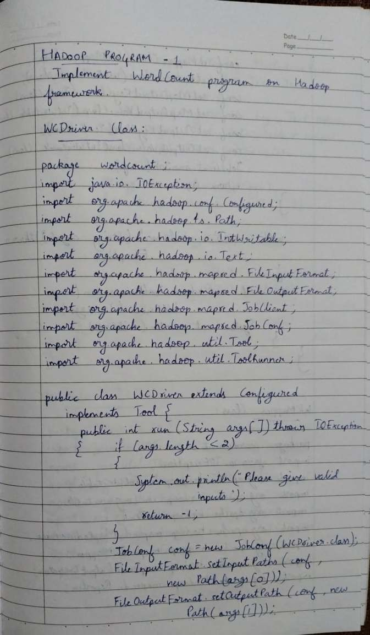

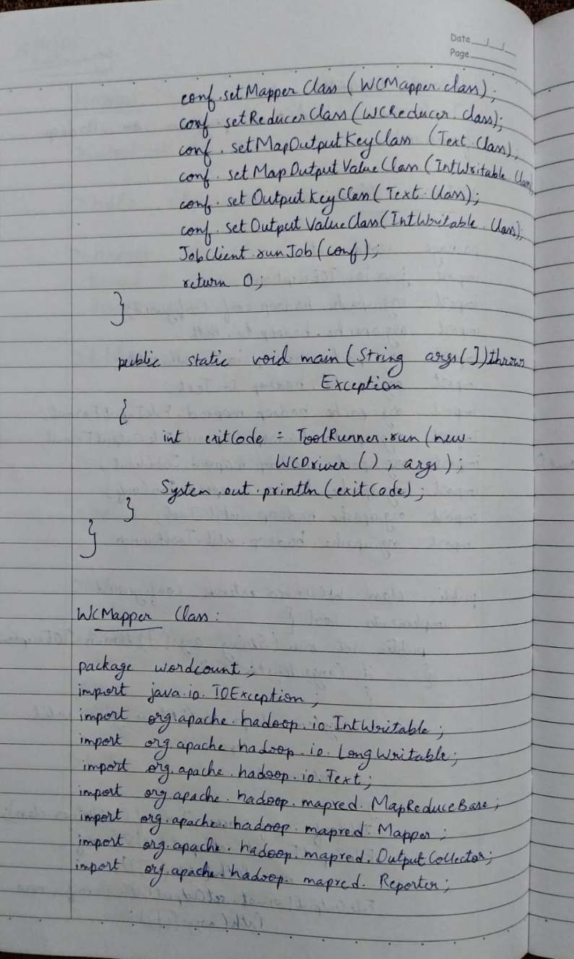

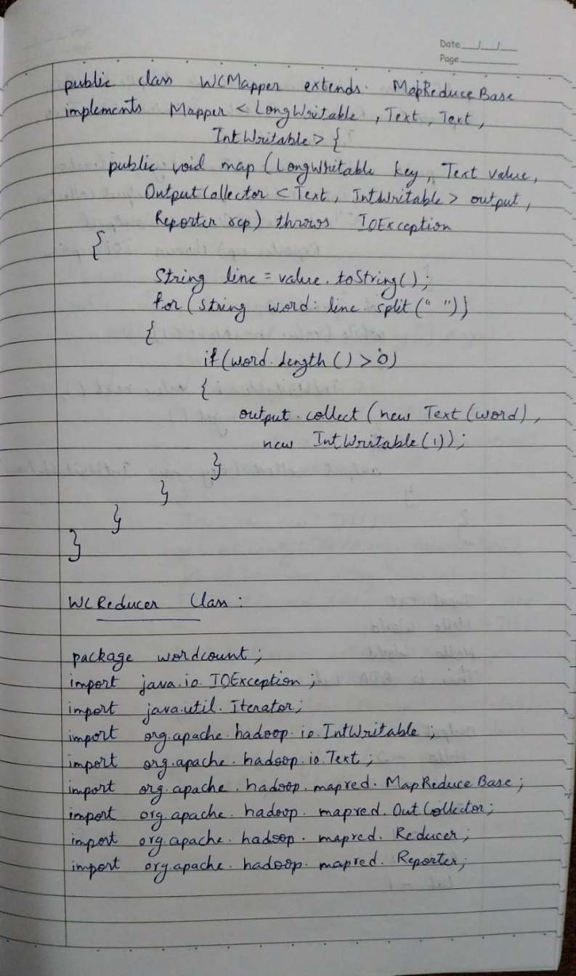

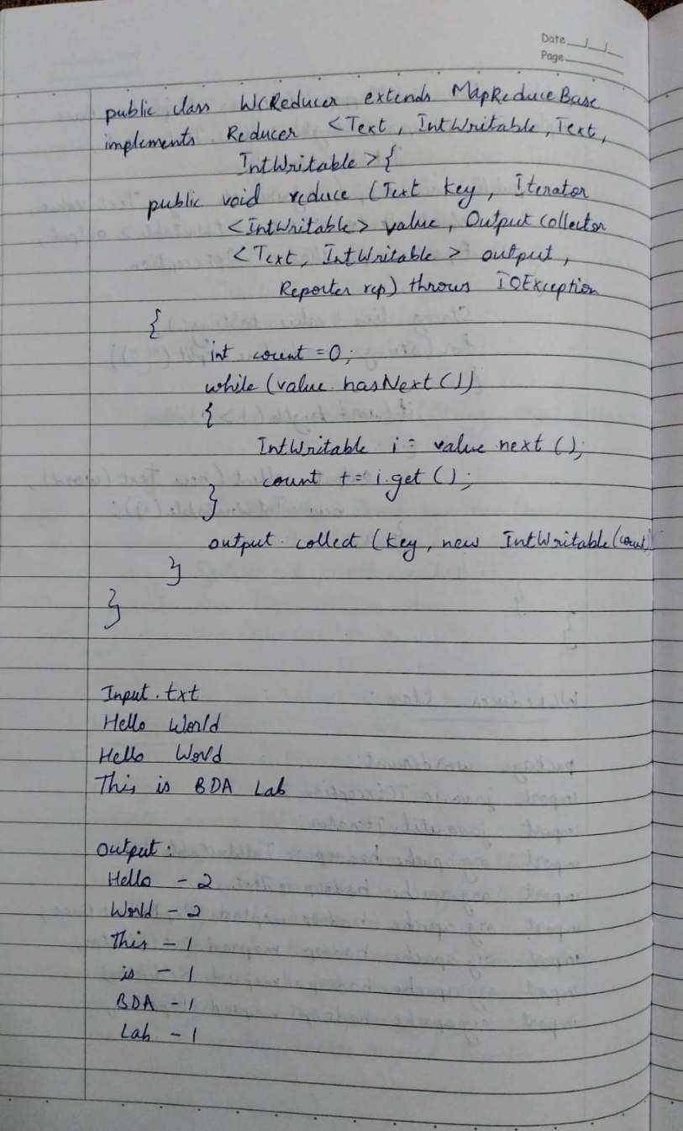

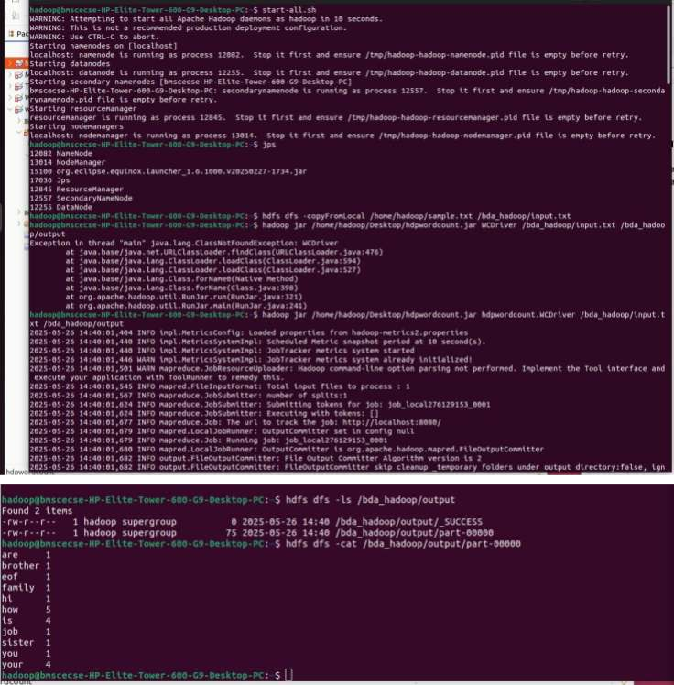**Code with Output:**

# Program 6

**From the following link extract the weather data**

https://github.com/tomwhite/hadoop-book/tree/master/input/ncdc/all

1. **Create a MapReduce program to find average temperature for each year from the NCDC data set.**
2. **find the mean max temperature for every month**

**Observation:**

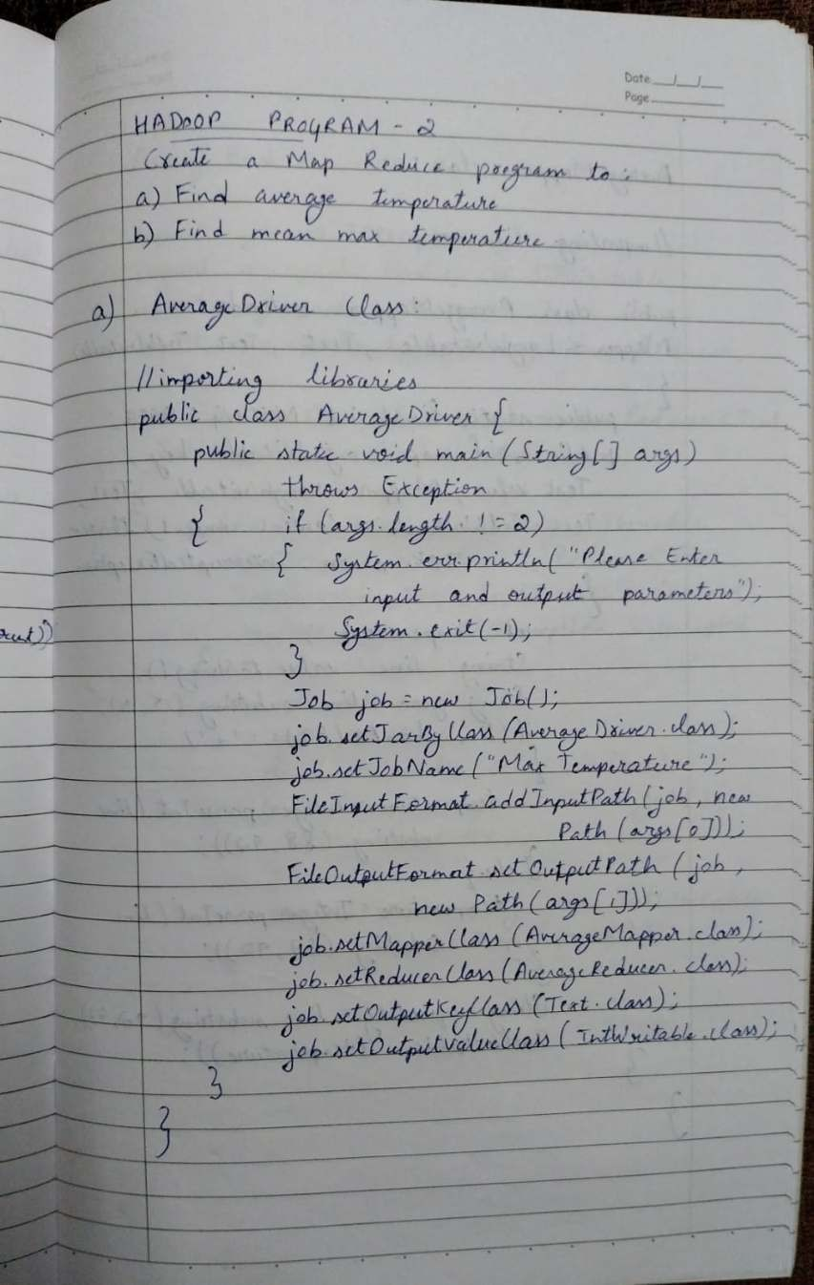

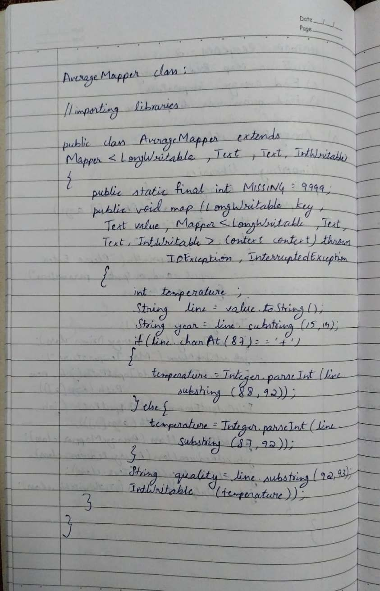

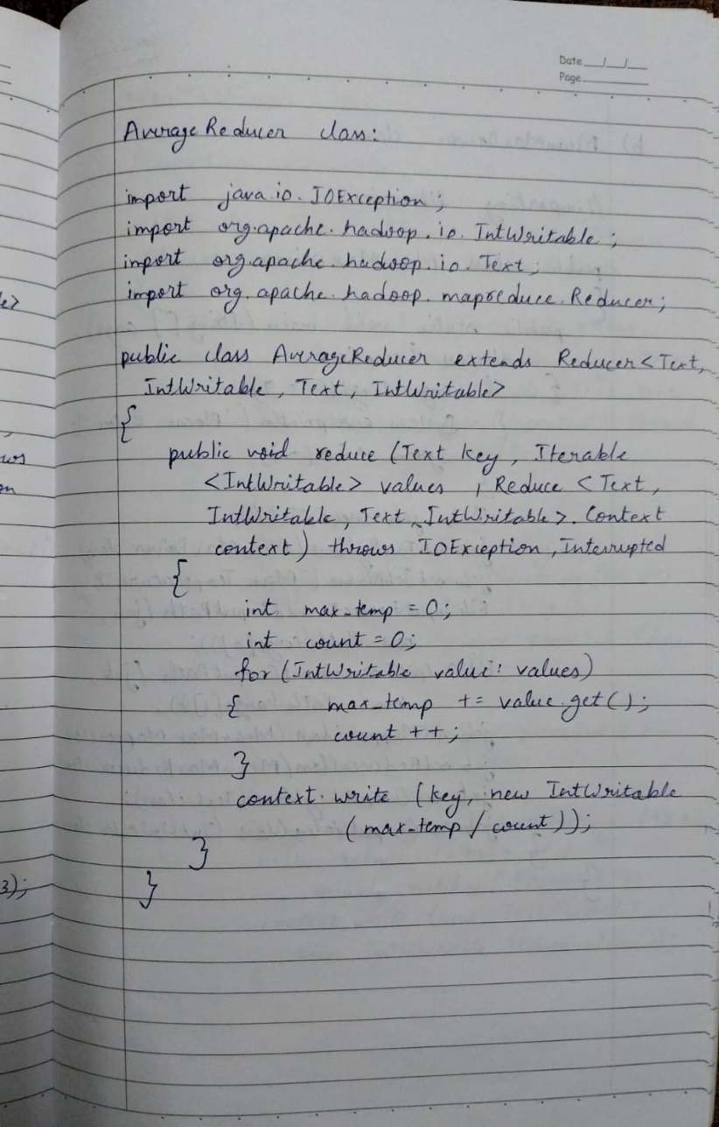

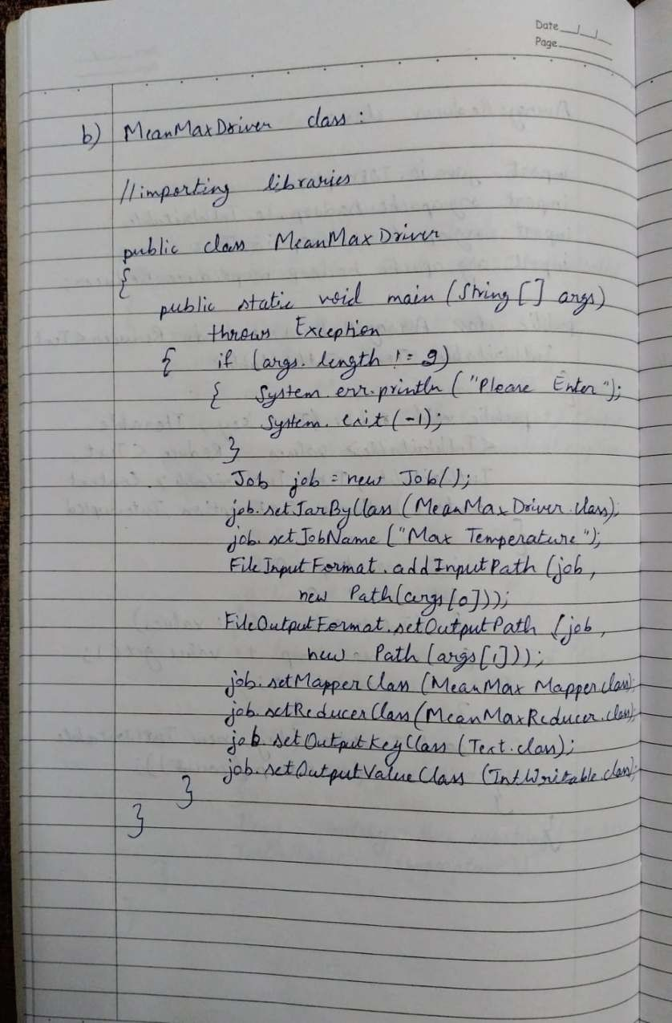

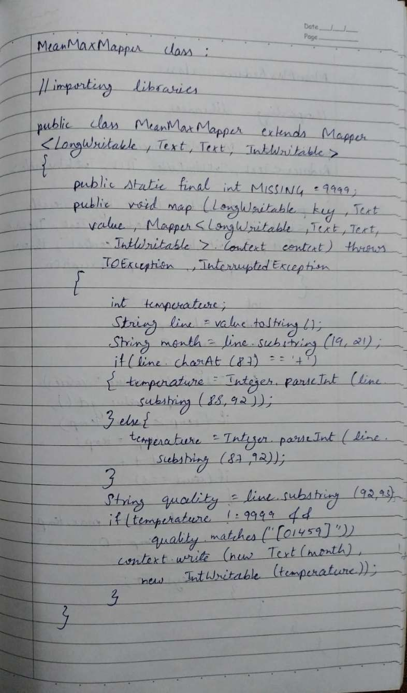

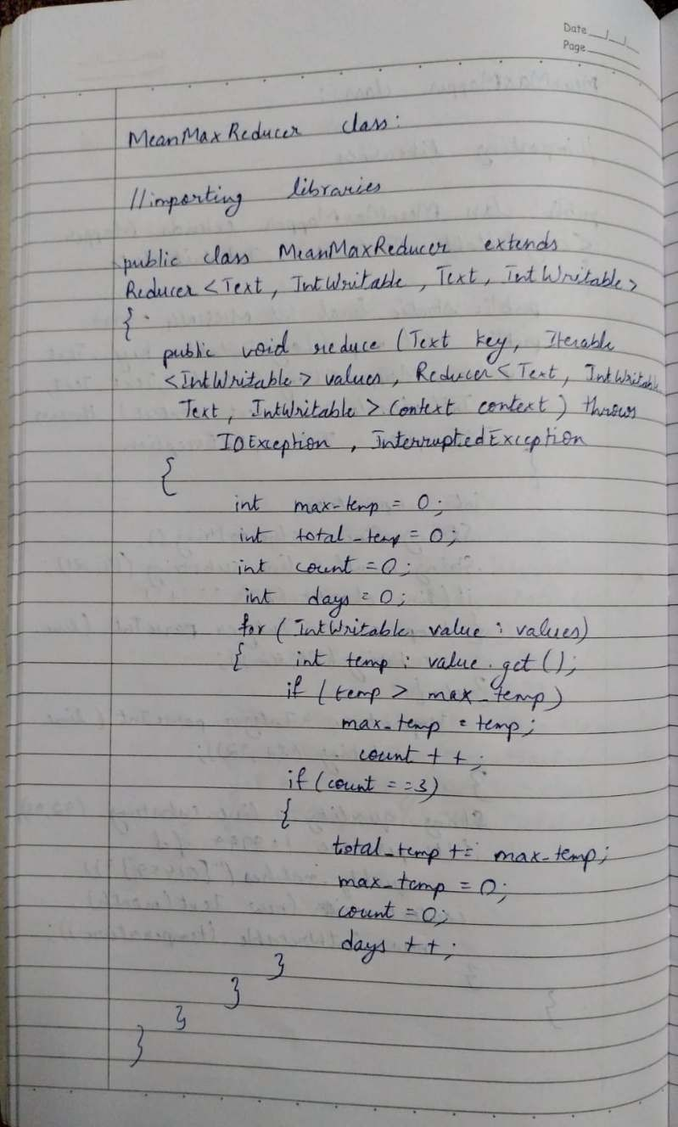

**Code with Output:**

1. **Average temperature**

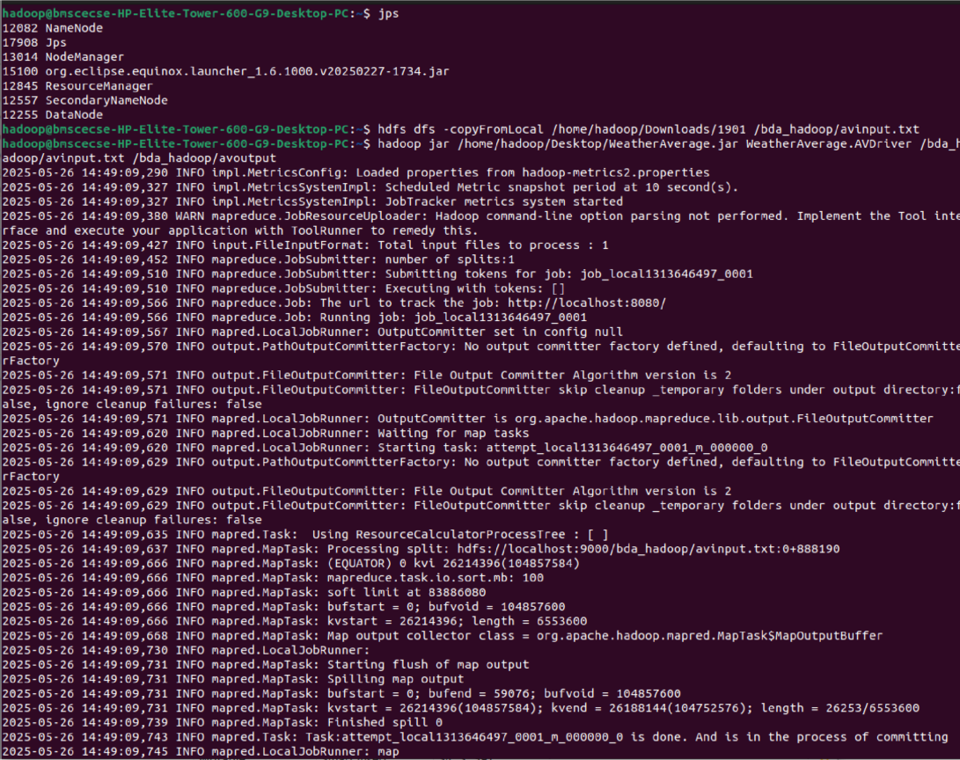

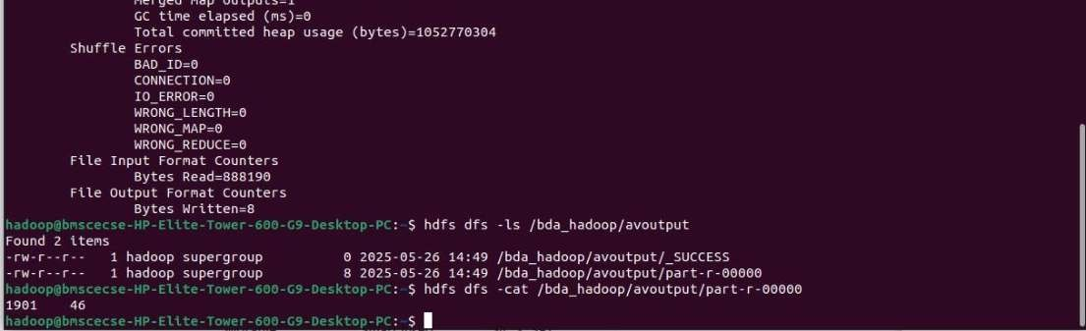

1. **Maximum temperature**

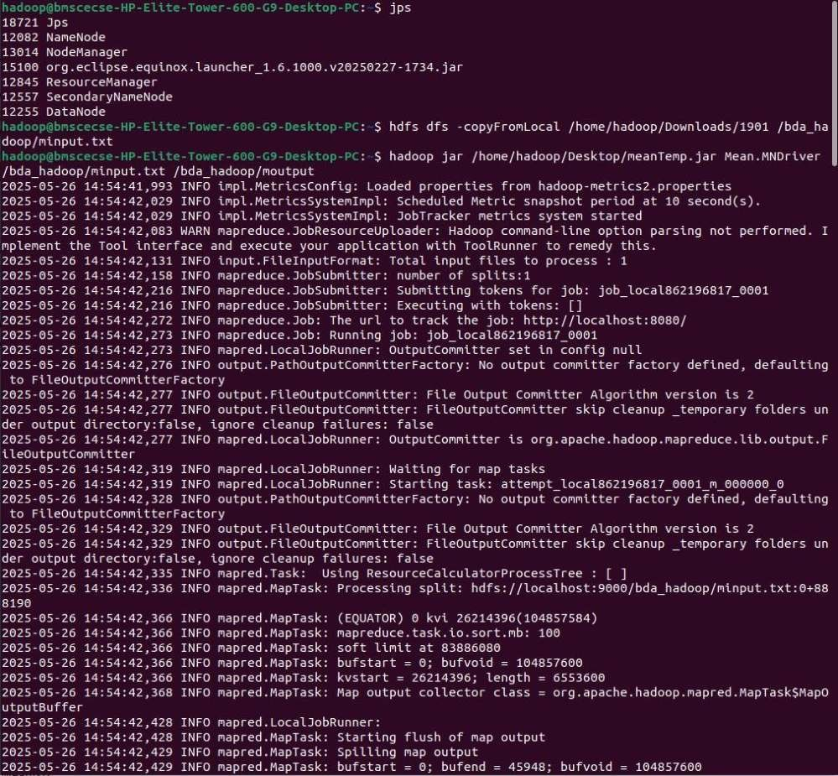

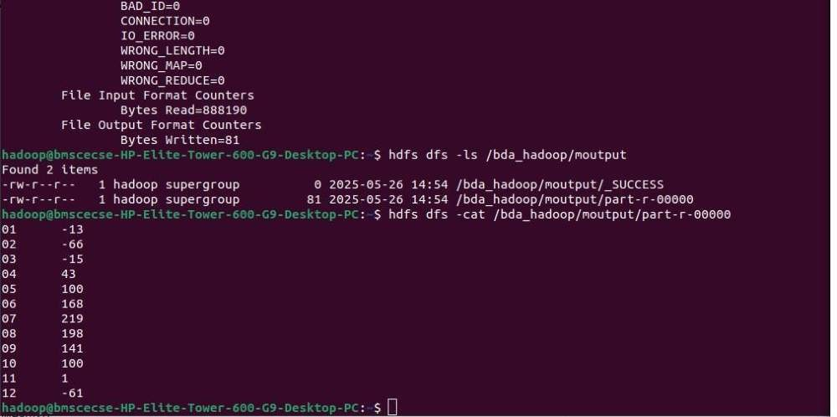

# Program 7

**For a given Text file, Create a Map Reduce program to sort the content in an alphabetic order listing only top 10 maximum occurrences of words.**

**Observation:**

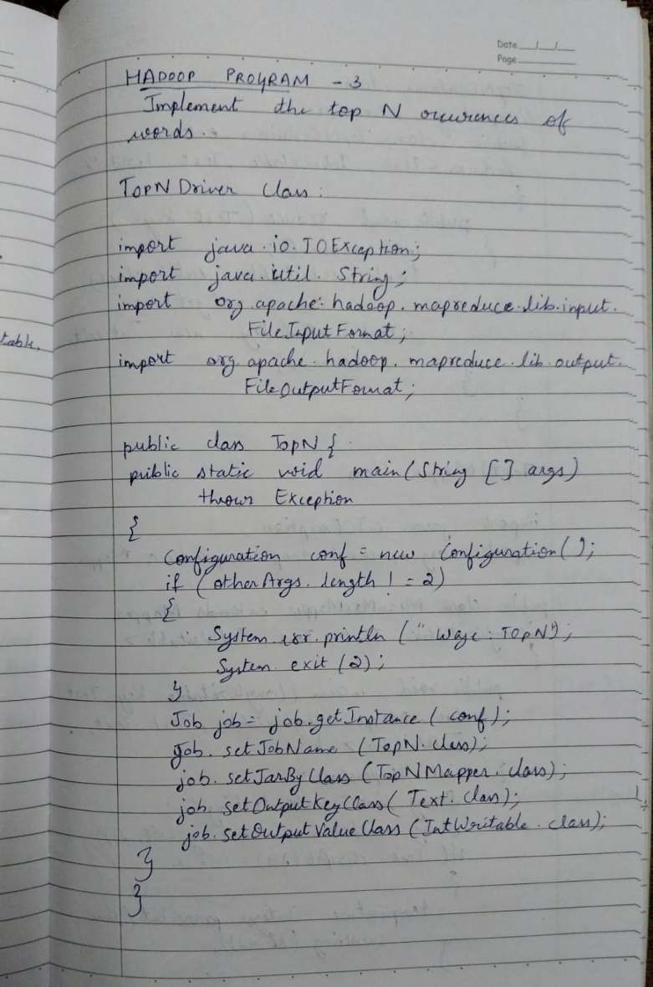

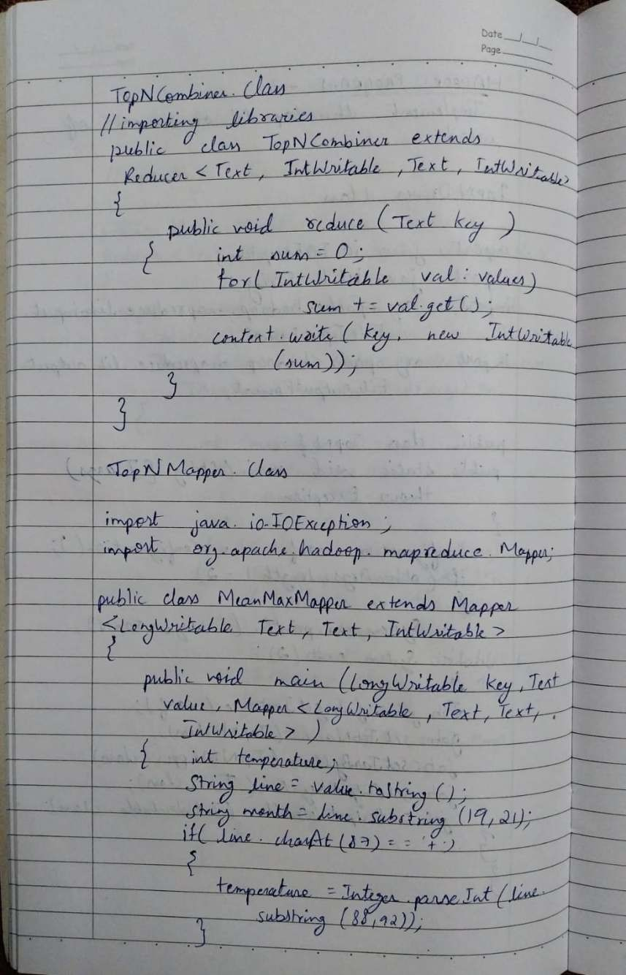

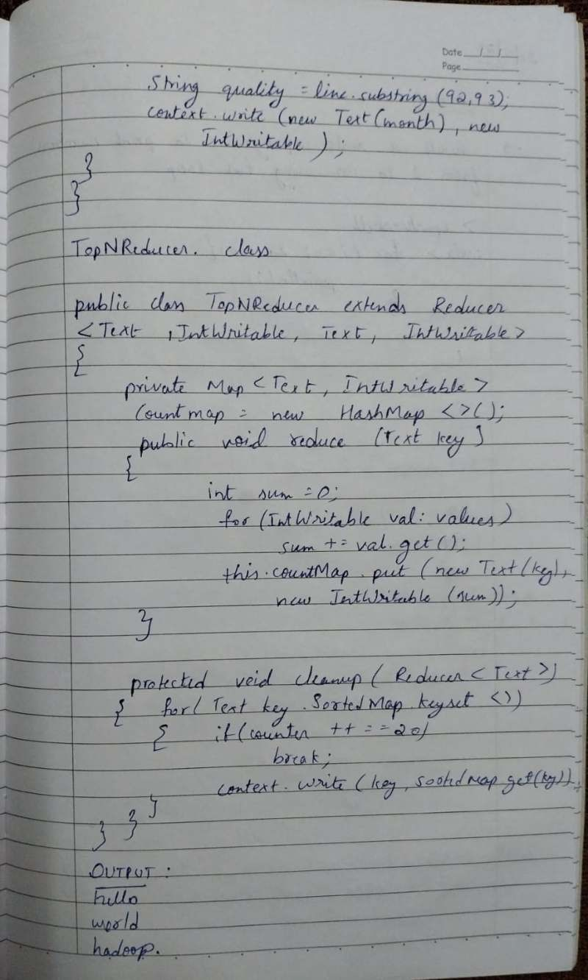

**Code with Output:**

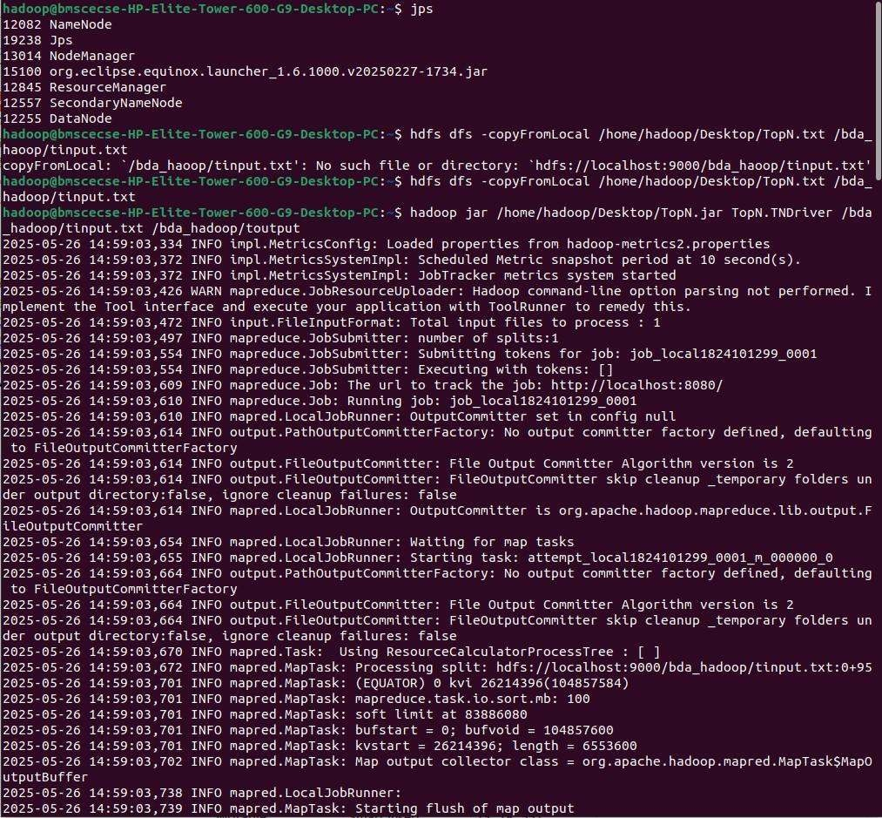

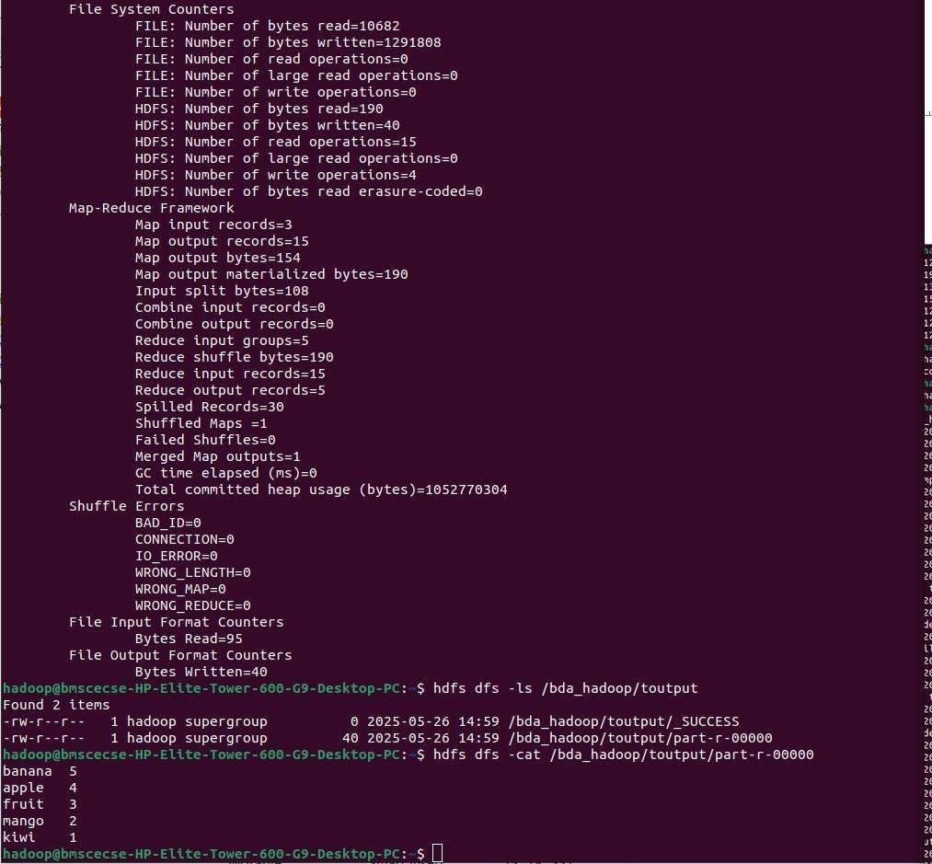

# Program 8

**Write a Scala program to print numbers from 1 to 100 using for loop.**

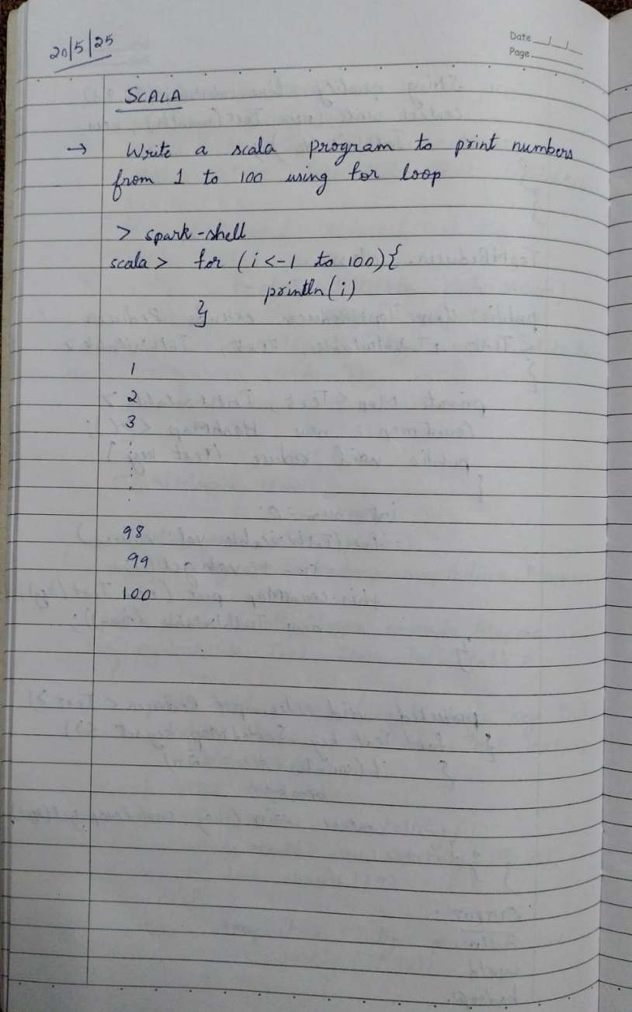**Observation:**

**Code with Output:**

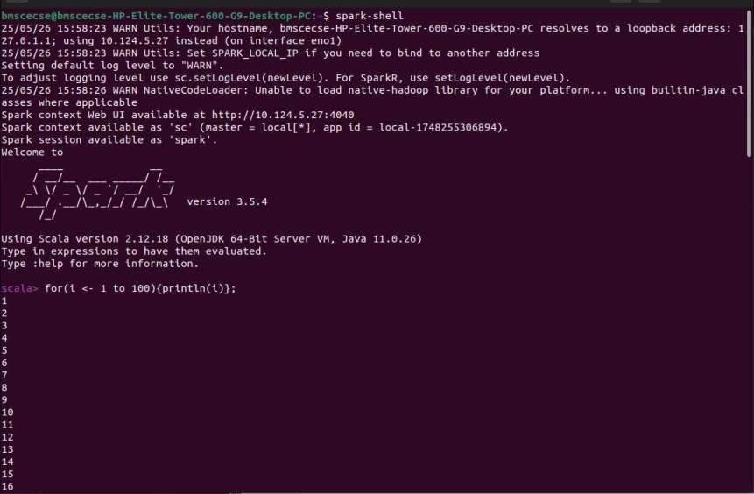

# Program 9

**Using RDD and FlatMap count how many times each word appears in a file and write out a list of words whose count is strictly greater than 4 using Spark**

**Observation:**

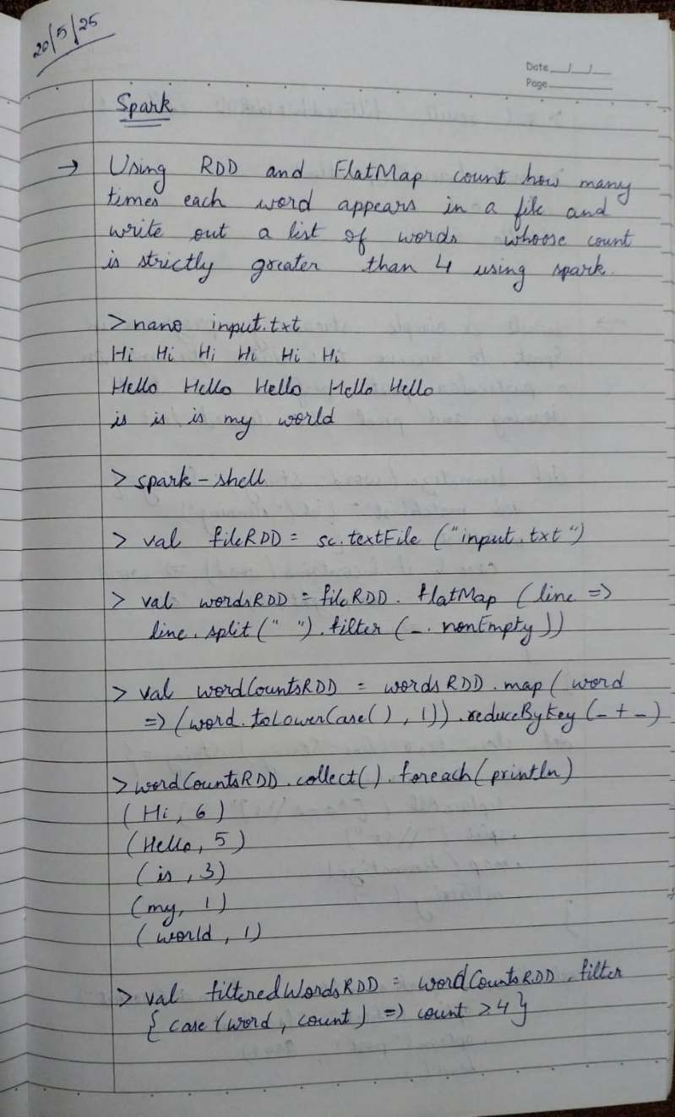

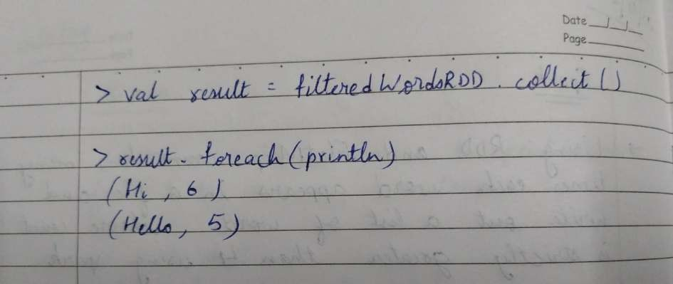

**Code with Output:**

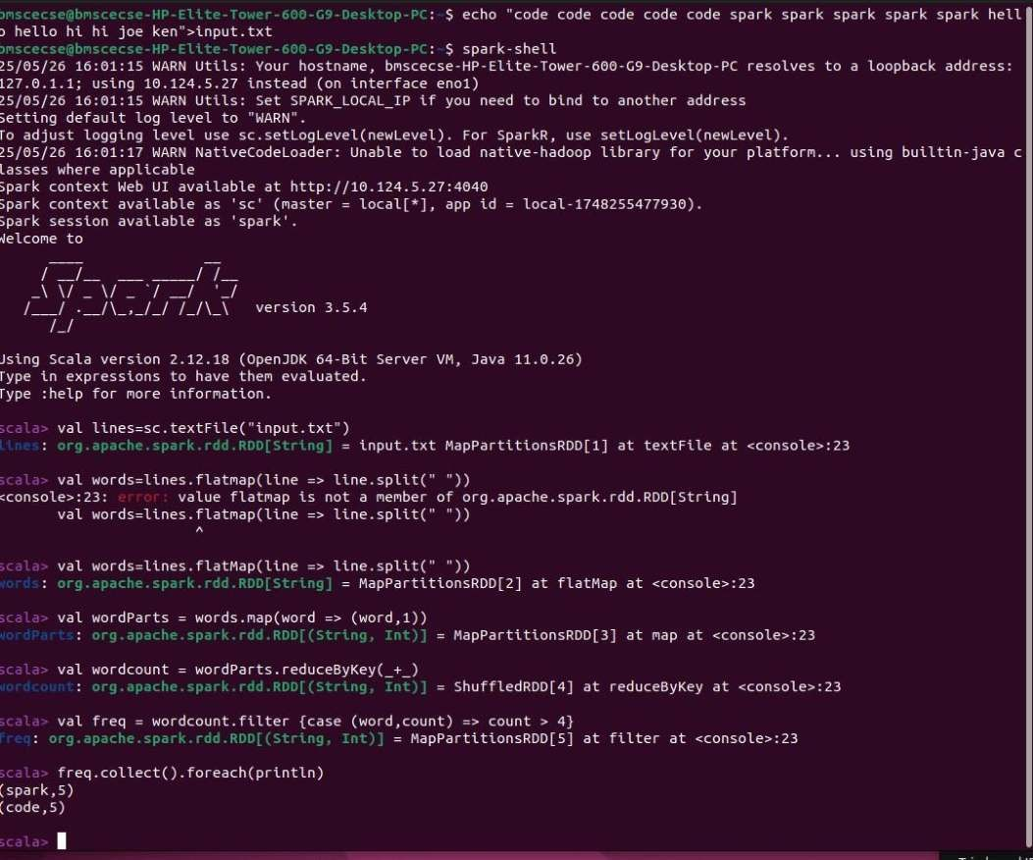

# Program 10

**Write a simple streaming program in Spark to receive text data streams on a particular port, perform basic text cleaning (like white space removal, stop words removal, lemmatization, etc.), and print the cleaned text on the screen. (Open Ended Question).**

**Observation:**



